AI-DASHBOARD

Name: Arjanit Pronaj

Abstract
This project presents a simulation of a small organization for anomaly detection in system and logs using artificial intelligence. The proposed architecture includes two Windows 11 computers acting as employees, a Windows Server 2022 serving as a Domain Controller, and an Ubuntu server dedicated to log collection, storage, and analysis. The goal is to demonstrate how logs can be centralized and processed with specialized tools to identify suspicious behaviors, such as unauthorized login attempts or unusual activities. The project integrates technologies such as NXLog and Python scripts with AI algorithms for anomaly detection. The expected outcome is to provide a practical foundation for understanding log collection and analysis, and to highlight the role of AI in enhancing information security.
Keywords: Artificial Intelligence, Anomaly Detection, Logs, Cybersecurity, Windows Server, Ubuntu

1. Introduction
This project aims to show how a small organization can build a practical system to analyze anomalies on computers and in the network using artificial intelligence. The idea is to create a simple environment that resembles a real organization, where there are employees, a domain server, and another server dedicated to log collection and analysis. In this way, the simulation helps to understand the process from the beginning up to the results, which provide insights about security and suspicious activities.
The main part of the project is composed of four virtual machines: two computers with Windows 11 that are used as employee workstations, one Windows Server 2022 machine that has the role of Domain Controller, and one Ubuntu machine that acts as the analysis center.
The Windows 11 computers generate logs for various activities, such as logins, application usage, or different errors. Windows Server 2022 manages users and stores domain-related logs, such as access attempts, security policies, and Active Directory events. Ubuntu is used to receive all these logs, store them, and analyze them using artificial intelligence techniques.
In this environment, logs are the main source of information. Through them, the organization can understand whether something abnormal is happening, such as attempts to log in with incorrect passwords, unnecessary use of privileges, or unusual activity on the network. The real-world problem is that the number of logs is very large, so it is difficult for a human to analyze them manually. For this reason, the use of AI is a helpful solution. AI models, such as anomaly detection algorithms, can automatically identify behaviors that deviate from the norm and signal when something suspicious occurs.

2. Main Aim of the Project
The main aim of this project is to create a practical scenario where the logs collected from the computers and the server are sent to a single central location, analyzed with specialized tools, and visualized through dashboards. In this way, the organization will have a clearer view of its security posture and will be able to react faster to incidents.
Furthermore, this simple structure can be used as a basis for further development, where more machines, other technologies, and more advanced AI algorithms can be added.
The concrete aims are:
- Building a practical lab for organizational simulation.
- Configuring the collection of logs from Windows 11 and Windows Server towards Ubuntu.
- Implementing a dataset in order to have data prepared for analysis.
- Using AI techniques to detect anomalies in logs.
- Documenting the project, the results, and recommendations for improving monitoring and incident response.

3. Working Methodology, Objectives and Expected Results
3.1 Working Methodology
- Initial research
The way Windows generates security logs, the structure of EventIDs, and the main event categories were analyzed. The goal was to identify the most important events for monitoring. This step defined the foundation for the system architecture.
- Definition of system requirements
The objectives were clearly defined: live log collection, secure storage, standardized processing, and AI-based analysis. It was also decided that the system should have an interactive dashboard with advanced filtering.
- Architecture design
A technical flow was designed: Windows → NXLog → Ubuntu → JSON/CSV → Python → Dashboard. The role of each component and how they interact with each other was defined.
- Configuration of log collection
NXLog was installed on PC1/PC2 and configured to read the Event Viewer in real time. Logs were converted to JSON and automatically sent to the Ubuntu server.
- Data normalization and filtering
Logs were cleaned from duplicates, unnecessary events were filtered out, and their fields were standardized. Live logs (JSON) were combined with the historical dataset (CSV).
- Analysis with artificial intelligence
The Isolation Forest algorithm was chosen for anomaly detection. The model analyzed log behavior and identified deviations that signal suspicious activities.
- Dashboard development
Using Dash and Plotly, a modern interface was created with interactive tables, time-series charts, severity charts, and intelligent alerting. The dashboard provides filtering by device, time, category, and AI tag.
- Practical testing of the system
A set of realistic events was simulated (failed logins, privilege escalation, process creation). The system was tested for stability, AI accuracy, and dashboard update speed.
- Documentation and finalization
All results were compiled, the technical chapters were prepared, and all technologies and processes were documented. Visualizations and methodological descriptions were finalized.

3.2 Objectives
- To establish a simple architecture for collecting and storing logs.
- To create pipelines for cleaning and normalizing logs.
- To apply AI models for anomaly detection.
- To evaluate the effectiveness of the models through metrics and test samples.

3.3 Expected Results
This project aims to achieve several practical results related to log collection and analysis using artificial intelligence.
The first result is the creation of a functional laboratory environment where all logs from Windows 11 computers and Windows Server 2022 are centralized on Ubuntu and stored in a structured format.
The second result is the ability to apply AI algorithms that identify unusual behaviors such as failed logins, attempts at unauthorized access, or abnormal use of privileges.
Another expected result is the construction of a dashboard in Python with the appropriate libraries, where administrators can visually see anomalies and network activity in real time.
In addition, the project aims to demonstrate how the combination of logs and AI can help organizations respond faster to security incidents, reducing the risk from cyberattacks.
In the end, this project is expected to serve as a practical and educational model, which can be expanded with more virtual machines, more advanced algorithms, and more complex security scenarios.

4. Technologies Used
- Windows Event Log
Windows Event Log is the primary security information source on PC1 and PC2. The system generates events related to authentication, processes, privileges, and critical system changes. These logs represent the foundation of security analysis and serve as direct input for the processing and AI phases.
- NXLog – Log collection agent
NXLog acts as an intermediary component between Windows and Ubuntu. It reads the Event Viewer in real time, converts all events into JSON format, and transmits them to the central server. This technology ensures reliable delivery, a uniform log format, and minimizes loss during transfer.
- Python
Python is used for all logical processes of the system:
  - loading and transforming logs,
  - data normalization,
  - executing the AI model,
  - building the interactive dashboard,
  - generating charts and statistics.
Thanks to its flexibility, Python allows easy integration between the log collector, the AI model, and the visualization layer.
- Pandas
Pandas is the main library for manipulating logs. It provides capabilities for filtering, removing duplicates, unifying JSON/CSV structures, and transformations that prepare the dataset for analysis by AI algorithms.
- scikit-learn – AI component
The AI model is based on the Isolation Forest algorithm, an efficient method for anomaly detection. It analyzes the structure of logs, compares current behavior with normal behavior, and identifies deviations that may indicate suspicious activity. This module significantly improves the system’s ability to detect exceptional events that are not easily spotted through traditional analysis.
- Dash – Dashboard interface
Dash is the framework that enables building the dashboard UI without using complex HTML or JavaScript. Through it, dynamic tables, interactive charts, and filtering mechanisms are created, giving the administrator a clear view of the security situation. Dash connects the Python backend with advanced Plotly visualizations.
- Plotly – Interactive visualizations
Plotly is used to create charts that present log activity, severity distribution, anomalies, and AI categories. These visualizations make analysis more intuitive and help in identifying trends and abnormal behaviors.

5. Environment Configuration
Lab :
- Windows 11 (PC1 & PC2) – represent the employees. They generate logs from daily activities (logins, application usage, network access).
- Windows Server 2022 (AD/DC) – acts as Domain Controller and DNS Server. It manages users, authentication, and generates domain logs (logins, security policies, login failures).
- Ubuntu (Collector/Analyzer) – central server that collects logs from PCs and Windows Server, processes them, and (optionally) stores them in Elasticsearch. On this VM, the Python scripts for anomaly analysis with AI are executed.
- Dashboard (Python) – served from Ubuntu, where logs and analysis results are visualized.
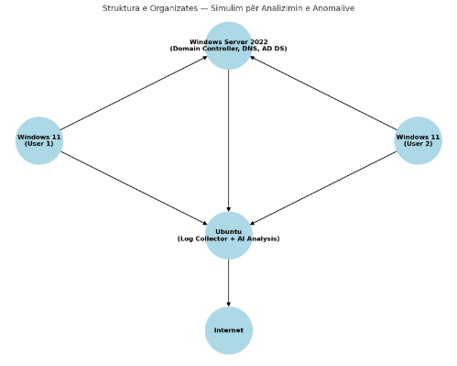
Figure 1: Structure of the Organization

5.1 Downloading and Configuring the Virtual Machines
For the realization of this project, four different virtual machines were used. The required ISO images were downloaded from official sources:
- Windows Server 2022 ISO – Microsoft Evaluation Center
- Windows 11 ISO – Microsoft Software Download
- Ubuntu Desktop LTS ISO – ubuntu.com/download
1. Creating Virtual Machines in VirtualBox
After downloading the ISOs, the virtual machines were created in Oracle VM VirtualBox.
Steps to create each VM:
- Open VirtualBox → New
- Set the VM name (e.g., Windows Server 2022 DC)
- Select the type:
  - Windows (64-bit) or
  - Linux (64-bit)
- Assign RAM and CPU:
  - Windows Server 2022: 4 GB RAM, 2 CPU
  - Windows 11 PC1 / PC2: 4 GB RAM, 2 CPU
  - Ubuntu Desktop: 4 GB RAM, 2 CPU
- Create a virtual disk of 60 GB (or as needed)
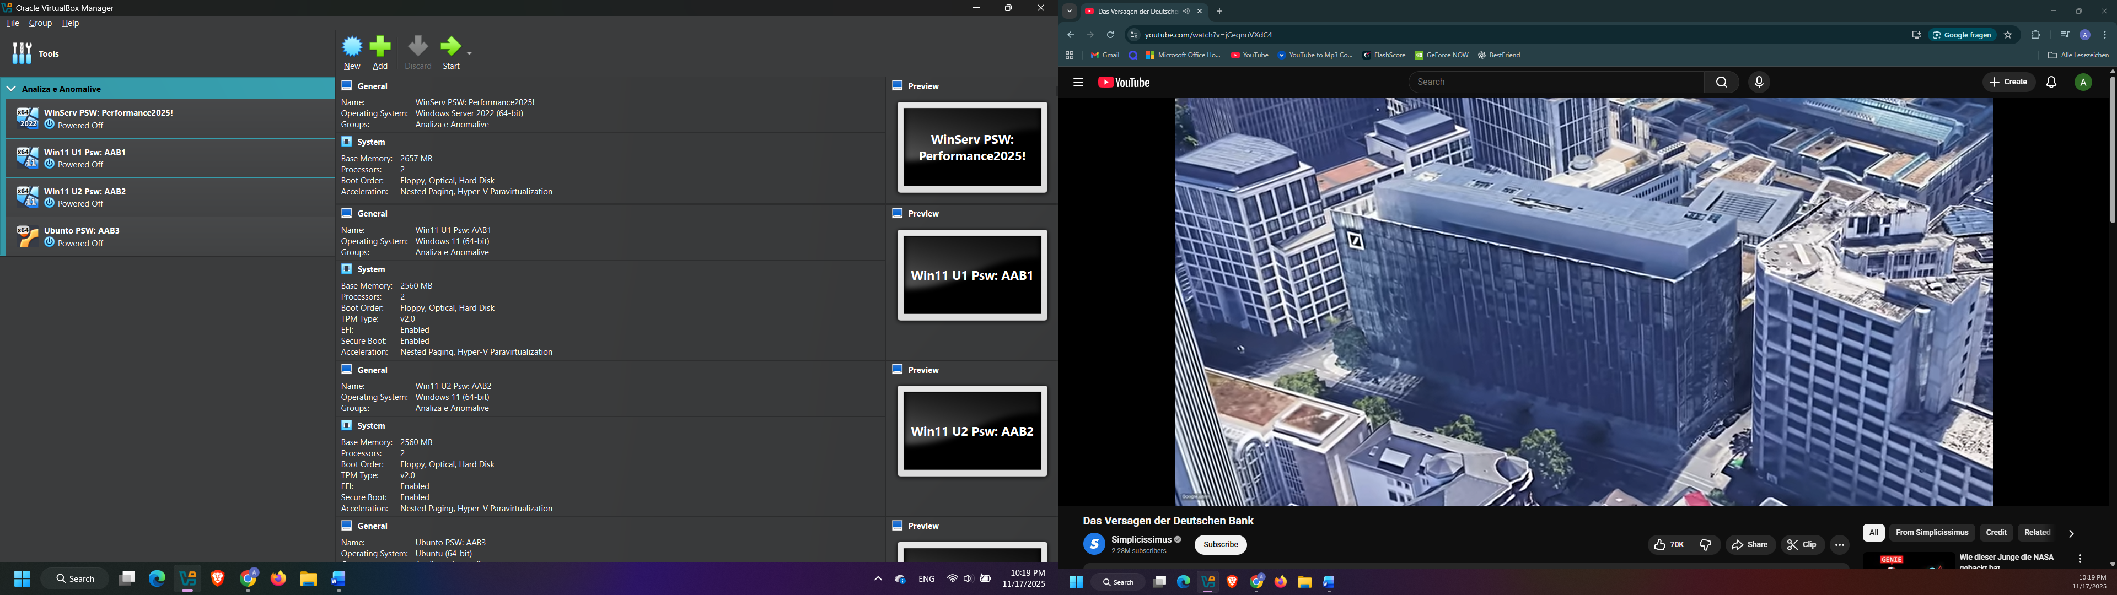
Figure 2: VirtualBox interface with the virtual machines

2. Configuring the NAT Network (ORGNET_NAT)
To ensure internal communication between the machines and access to the internet, a custom NAT Network was created.
Steps:
- In VirtualBox, go to File → Tools → Network Manager
- Choose NAT Networks
- Click Create
- Set:
  - Name: ORGNET_NAT
  - Network CIDR: 192.168.100.0/24
  - DHCP: Disabled (because static IPs are used)
  - Supports IPv6: OFF
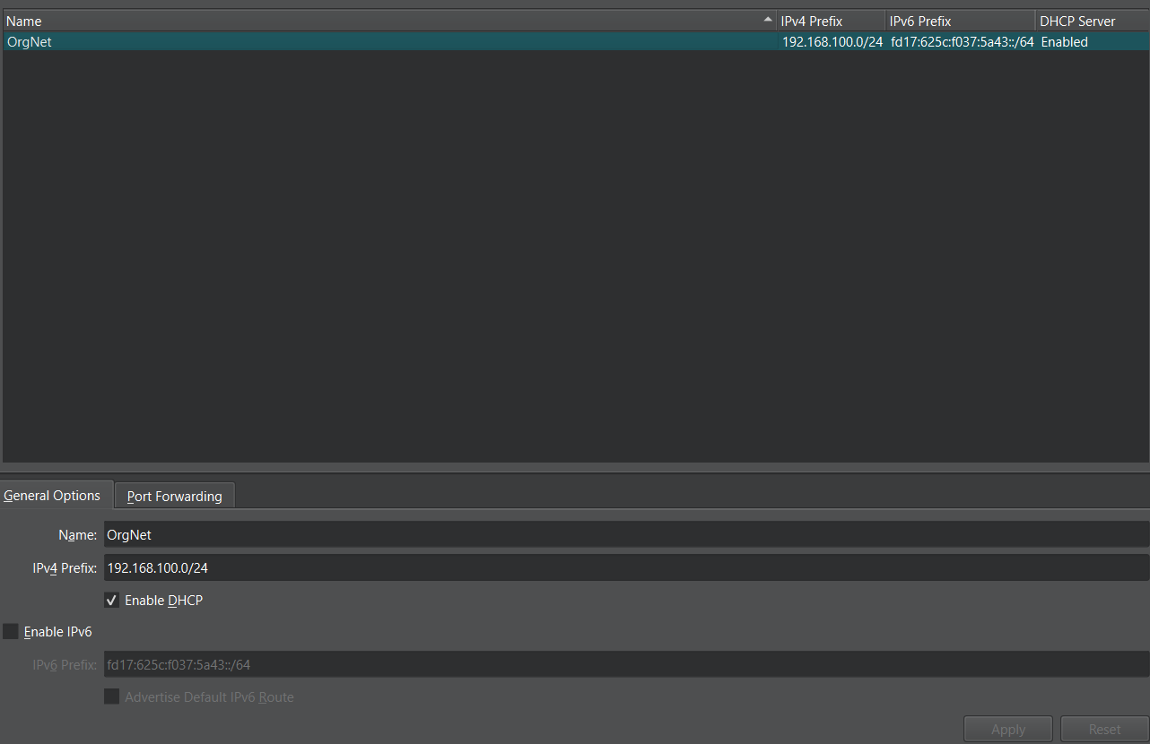
Figure 3: Configured NAT Network ORGNET_NAT

3. Assigning ORGNET_NAT to each VM
On each virtual machine:
- VM Settings → Network
- Adapter 1: Attached to: NAT Network
- Name: ORGNET_NAT
This ensures that all machines are in the same virtual subnet.

4. Initial verification of machine functionality
After installation and initial configuration:
- Check that all machines boot without problems
- Check that keyboard, network, and display work correctly in VirtualBox
- Ensure that all VMs can be pinged after static IPs are set (next chapter)
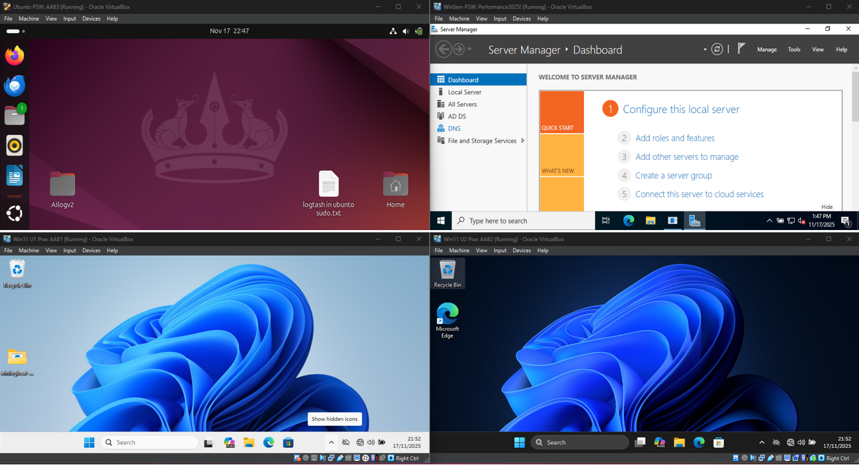
Figure 4: Final list of the four virtual machines in VirtualBox

4.2 Manual Assignment of IPs for the Orgnet Network
This section defines the step-by-step method to manually assign IP addresses for all machines in the Orgnet.local network so that they can communicate with each other and connect to the Domain Controller (Windows Server 2022).
Network Structure
Device | IP Address | Subnet Mask | Gateway | DNS Server
Windows Server 2022 | 192.168.100.10 | 255.255.255.0 | 192.168.100.1 | 192.168.100.10
PC1 (Windows 11) | 192.168.100.11 | 255.255.255.0 | 192.168.100.1 | 192.168.100.10
PC2 (Windows 11) | 192.168.100.12 | 255.255.255.0 | 192.168.100.1 | 192.168.100.10
Ubuntu (Standard) | 192.168.100.13 | 255.255.255.0 | 192.168.100.1 | 192.168.100.10
Figure 5: Network structure table

4.2.1 Windows Server 2022 — IP Assignment with PowerShell
Step 1: Remove existing IP and Gateway
Get-NetIPAddress -InterfaceAlias "Ethernet" -AddressFamily IPv4 | Remove-NetIPAddress -Confirm:$false -ErrorAction SilentlyContinue
Get-NetRoute -InterfaceAlias "Ethernet" -AddressFamily IPv4 | Where-Object {$_.DestinationPrefix -eq "0.0.0.0/0"} | Remove-NetRoute -Confirm:$false -ErrorAction SilentlyContinue
Step 2: Set static IP
New-NetIPAddress -InterfaceAlias "Ethernet" -IPAddress 192.168.100.10 -PrefixLength 24 -DefaultGateway 192.168.100.1
Step 3: Set DNS (itself)
Set-DnsClientServerAddress -InterfaceAlias "Ethernet" -ServerAddresses 192.168.100.10
Step 4: Allow ping (optional but recommended for network testing)
New-NetFirewallRule -DisplayName "Allow ICMPv4-In" -Protocol ICMPv4 -Direction Inbound -Action Allow
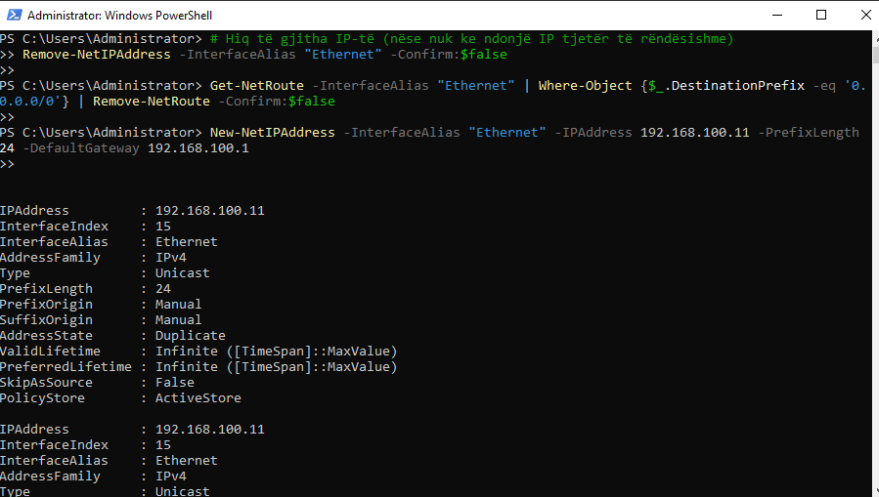
Figure 6: : IP assignment with PowerShell for Windows Server

5.2.2 PC1 (Windows 11) — IP Assignment with PowerShell
Step 1: Remove existing IP and gateway
Remove-NetIPAddress -InterfaceAlias "Ethernet" -Confirm:$false
Get-NetIPAddress -InterfaceAlias "Ethernet" | Remove-NetIPAddress -Confirm:$false -ErrorAction SilentlyContinue
Get-NetRoute -InterfaceAlias "Ethernet" | Where-Object {$_.DestinationPrefix -eq "0.0.0.0/0"} | Remove-NetRoute -Confirm:$false
Step 2: Set static IP
New-NetIPAddress -InterfaceAlias "Ethernet" -IPAddress 192.168.100.11 -PrefixLength 24 -DefaultGateway 192.168.100.1
Step 3: Set DNS to point to the Server
Set-DnsClientServerAddress -InterfaceAlias "Ethernet" -ServerAddresses 192.168.100.10
Step 4: Check connectivity
ping 192.168.100.10

5.2.3 PC2 (Windows 11) — IP Assignment with PowerShell
Step 1: Remove existing IP
Remove-NetIPAddress -InterfaceAlias "Ethernet" -Confirm:$false
Get-NetIPAddress -InterfaceAlias "Ethernet" | Remove-NetIPAddress -Confirm:$false -ErrorAction SilentlyContinue
Get-NetRoute -InterfaceAlias "Ethernet" | Where-Object {$_.DestinationPrefix -eq "0.0.0.0/0"} | Remove-NetRoute -Confirm:$false
Step 2: Set static IP
New-NetIPAddress -InterfaceAlias "Ethernet" -IPAddress 192.168.100.12 -PrefixLength 24 -DefaultGateway 192.168.100.1
Step 3: Set the Server’s DNS
Set-DnsClientServerAddress -InterfaceAlias "Ethernet" -ServerAddresses 192.168.100.10

Figure 7: IP assignment with PowerShell on Windows 11

4.2.4 Ubuntu — IP Assignment with Terminal Commands
Step 1: Show active connections
nmcli connection show
Find the connection name, usually "Wired connection 1".
Step 2: Set static IP
sudo nmcli connection modify "Wired connection 1" ipv4.addresses 192.168.100.13/24
sudo nmcli connection modify "Wired connection 1" ipv4.gateway 192.168.100.1
sudo nmcli connection modify "Wired connection 1" ipv4.dns 192.168.100.10
sudo nmcli connection modify "Wired connection 1" ipv4.method manual
sudo nmcli connection up "Wired connection 1"
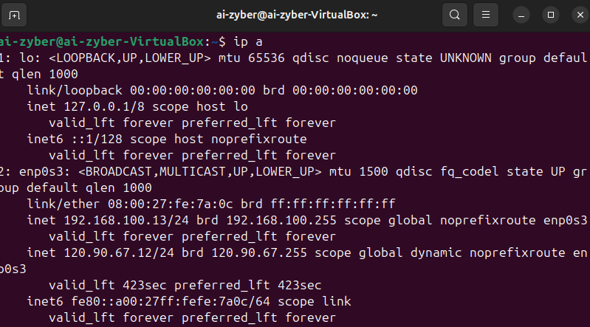
Figure 8: IP assignment with the Terminal on Ubuntu

4.3 Joining all Machines (Windows & Ubuntu) to the ORGNET.LOCAL Domain
This section describes the step-by-step procedure for joining:
- Windows Server 2022 (Domain Controller),
- PC1 and PC2 (Windows 11),
- Ubuntu Standard (Log Analysis Server),
into a unified organization with Active Directory under the domain orgnet.local.

4.3.1 Part on Windows Server 2022 – AD Domain Controller
This part is done once and is already completed:
Install-WindowsFeature AD-Domain-Services -IncludeManagementTools
Install-ADDSForest -DomainName "orgnet.local"
The server creates the orgnet.local domain and acts as DNS for the network.
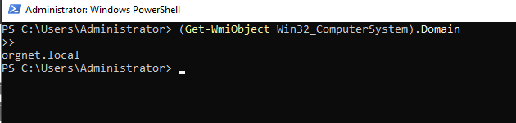
Figure 9: Creation and identification of the orgnet.local organization

4.3.2 Joining PC1 & PC2 to the Domain
In PowerShell (Run as Administrator):
Add-Computer -DomainName "orgnet.local" -Credential orgnet\Administrator
Restart-Computer
After the restart, at the login screen you will see:
Sign in to: ORGNET
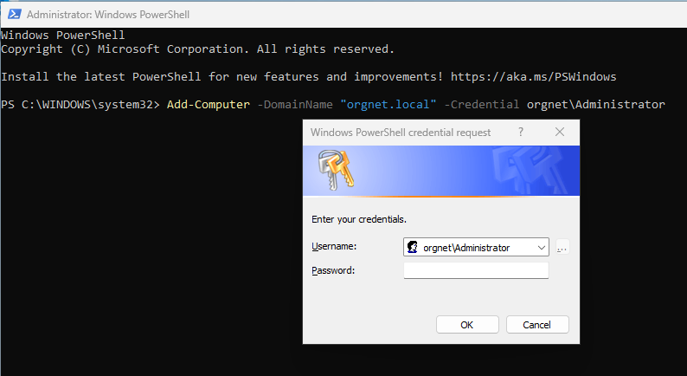
Figure 10: Joining PC1 & PC2 to the Domain via PowerShell

4.3.3 Joining Ubuntu to the Domain
Step 1: Update the system
sudo apt update && sudo apt upgrade -y
Step 2: Install packages for AD integration
sudo apt install realmd sssd sssd-tools adcli samba-common krb5-user packagekit -y
During the installation of krb5-user, when asked for Default Kerberos realm, type:
ORGNET.LOCAL
Step 3: Check that Ubuntu can see the domain
realm discover orgnet.local
If everything is correct, domain information will be shown.
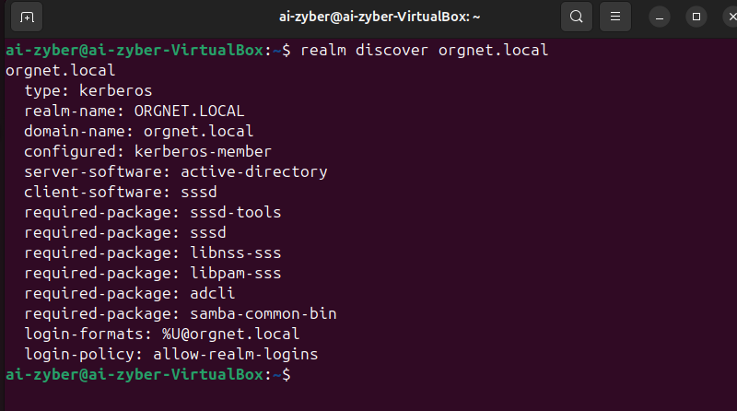
Figure 11: Identification of the orgnet.local Domain on Ubuntu
Step 4: Join Ubuntu to the domain
sudo realm join --user=Administrator orgnet.local
The password is the password of the Administrator account on Windows Server.
If the join is successful, then the command output confirms the connection.
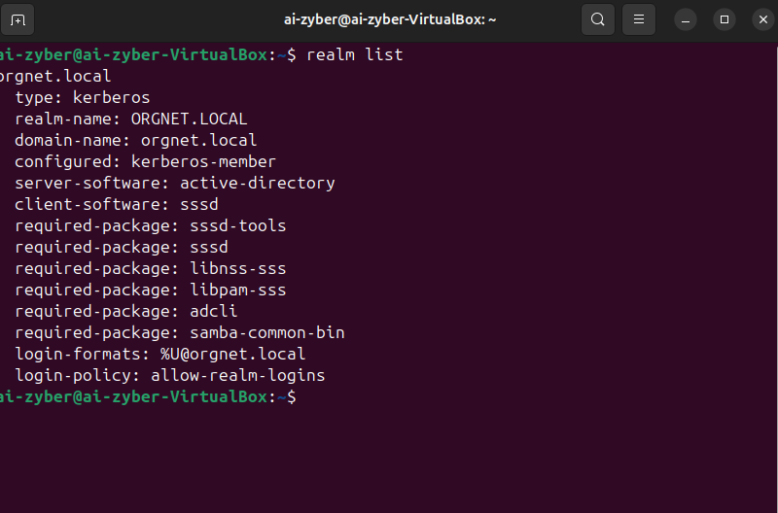

Figure 12: Verification of Ubuntu’s connection to the Domain

Step 5: Allow logins with domain users
sudo pam-auth-update
Then enable the relevant options from the interface.
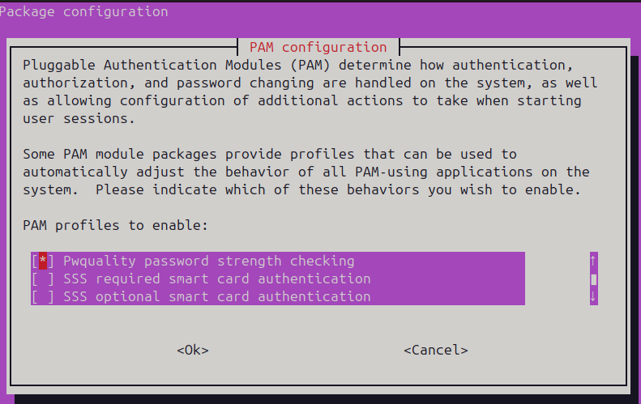
Figure 13: Final phase of enabling login with Domain users

5.3.4 Verification from Windows Server
On Windows Server, in AD Administrative Center, the joined machines should be visible.
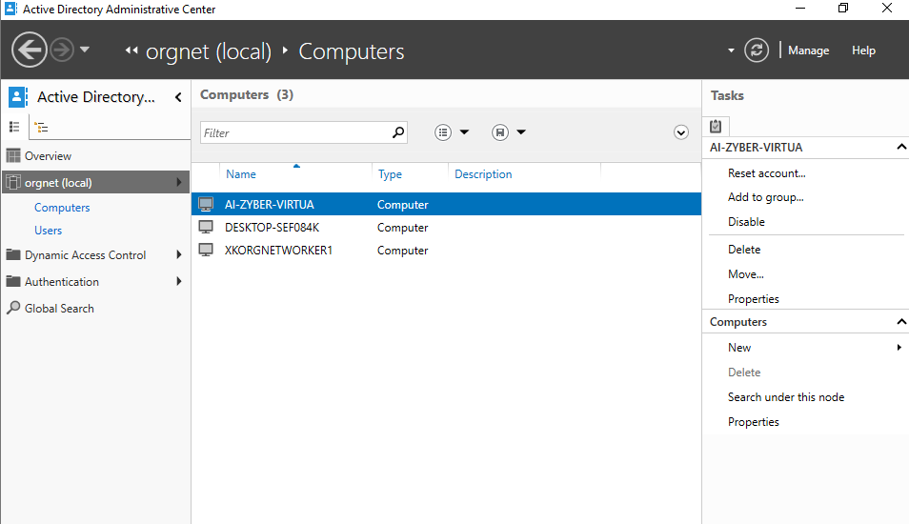
Figure 14: Domain interface on orgnet.local

4.3 Receiving Logs on Ubuntu
4.3.1 Installation and Configuration of NXLog on PC1 & PC2
- Download NXLog Community Edition (https://nxlog.co/products/nxlog-community-edition) on PC1 & PC2.
- Go to the NXLog installation path.
- Enter the configuration folder, open the config file with Notepad and add the script for sending logs to Ubuntu.
- Start the NXLog service.
- Check the NXLog service status.
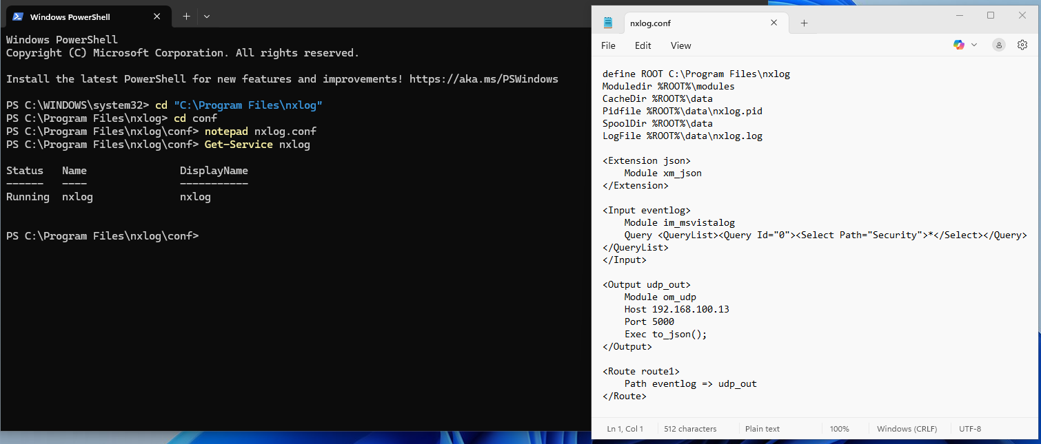
Figure 15: NXLog configuration on Windows 11

4.3.2 Log Collector on Ubuntu
Using Python, a script is created that receives logs from the network on the appropriate port.
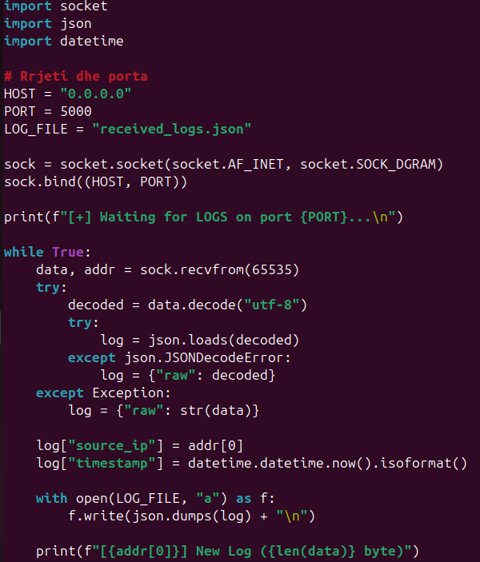
Figure 16: Python script for collecting logs on Ubuntu

Here, the script receives logs from PC1 and PC2 and saves them in a JSON file:
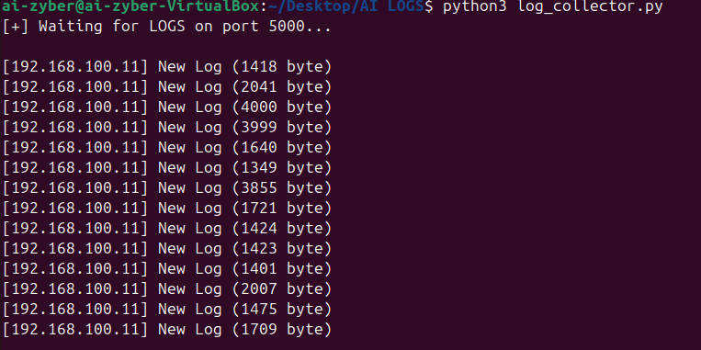
Figure 17: Execution of log_collector.py

Test: perform login/logout on PC1/PC2 and run:
tail -n 5 received_logs.json
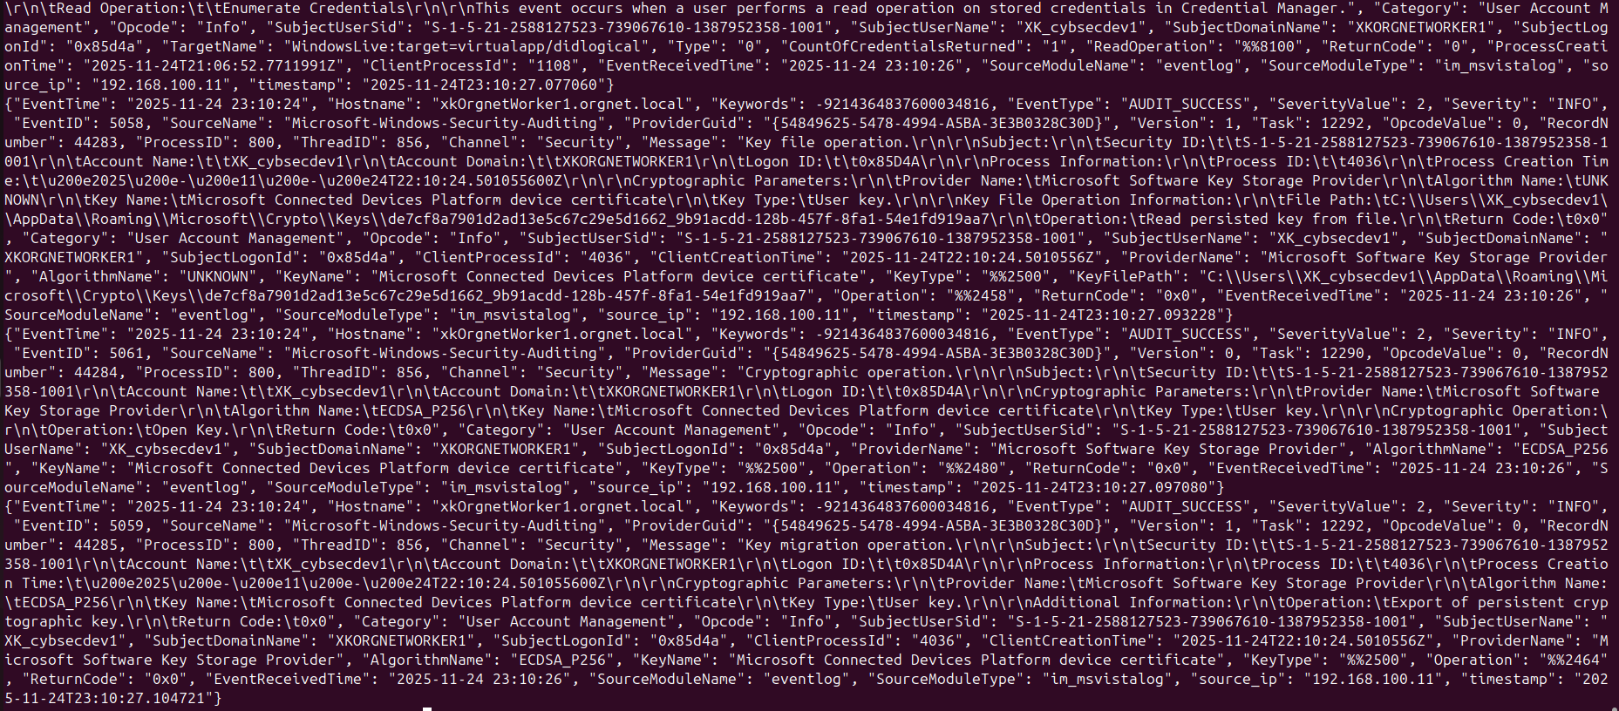

Figure 18: Content of received_logs.json

4.4 AI Dashboard on Ubuntu
The AI Dashboard on Ubuntu is built as a central platform for collecting, processing, and analyzing security logs generated by network devices, particularly PC1 and PC2. Through this system, continuous monitoring of system activity, identification of abnormal behaviors, and real-time risk assessment are enabled.
The dashboard performs log centralization, automatic event analysis, anomaly detection with AI, EventID categorization, and intelligent alerting for every high-risk event. Thanks to data normalization and interactive visual presentation, the administrator has a clear overview of the system’s security state and can react more quickly to potential incidents.

5.4.2 Architecture of the AI Component
The architecture of the AI component in the dashboard is designed to ensure accurate and stable processing of security logs. It consists of several layers that collaborate to normalize data, detect deviations from normal behavior, and categorize events by risk level.
First, the system receives logs from JSON and CSV sources, which are unified into a standardized structure for further analysis. Then, data cleaning is performed by removing duplicates, filtering out unnecessary logs, and fixing inconsistent fields.
In the AI phase, the anomaly detection model (Isolation Forest) is applied, which evaluates events based on the typical behavior of the system. In parallel, the EventID classifier operates, categorizing events into clear groups such as Failed Authentication, Process Creation, Privilege Escalation, Credential Access, and Policy/Service Changes, giving administrators a clear and understandable view of system activity.

5.4.3 Executing the Dashboard
The dashboard is executed on the Ubuntu platform through a Python virtual environment, which ensures library isolation and stable application operation.
First, a virtual environment (venv) is created and the required packages such as Dash, Plotly, pandas, and scikit-learn are installed. After configuring the environment, the dashboard is started by running the main application file (dashboard.py).
The system starts on port 8050 and is accessible via a web browser from any device within the local network. This execution model offers ease of use, immediate interactivity, and the possibility of later expansion without structural changes.
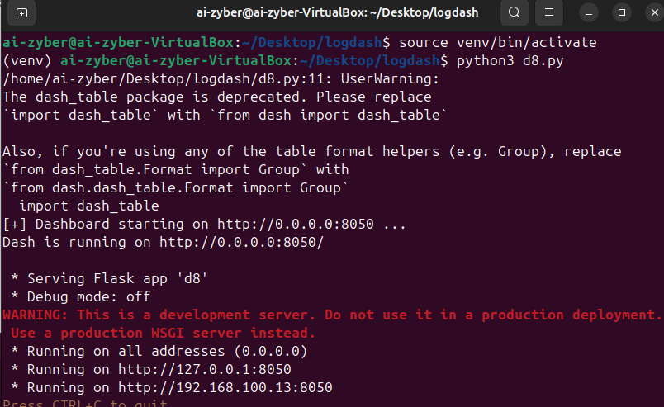
Figure 19: Execution of the dashboard

4.4.4 Main Functionalities
The AI Dashboard includes a set of functionalities that make security log monitoring fast, clear, and practical.
- The main functionality is advanced filtering, which allows searching logs by device, time interval, and AI-defined risk level. This helps to immediately identify high-priority events.
- The system provides interactive visual charts to display event trends, AI severity distribution, and AI score changes over time. These charts make analysis more intuitive and help detect suspicious deviations in system behavior.
- Logs are displayed in a single unified table, where live data from JSON is combined with historical data from CSV. Each row contains the original log information along with AI assessments such as severity, tag, and score, without altering the base data.
- An important functionality is the Alert Box, which automatically displays critical events according to a threshold set by the user. In this way, the administrator’s attention is immediately drawn to the most dangerous cases.
- The dashboard also includes dynamic device management, allowing the addition, update, or deletion of hosts without changing the application structure. This makes the system flexible and easy to expand.
Overall, the main functionalities of the AI Dashboard turn log collection into a centralized, automated, and intelligent process, significantly improving efficiency and accuracy in monitoring system security.
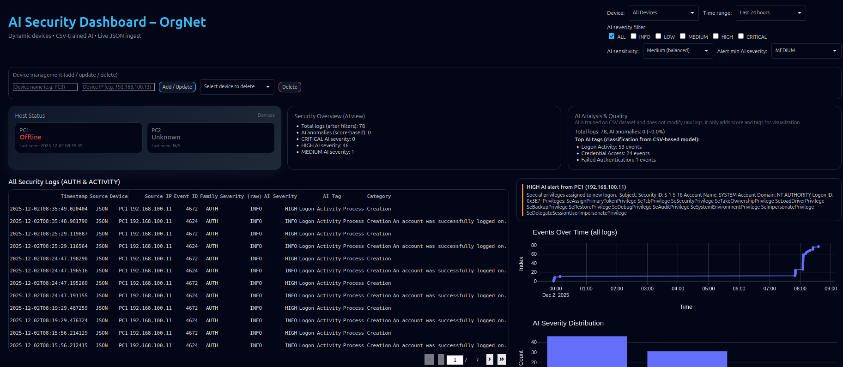
Figure 20: Dashboard interface
5. Conclusion
The implemented project demonstrated in a practical way how a small organization can build a complete security monitoring chain, starting from log generation on workstations and servers, up to intelligent analysis and final visualization in an AI Dashboard.
The designed architecture – with two Windows 11 PCs, a Windows Server 2022 as Domain Controller, and an Ubuntu machine as collector/analyzer – showed that even with readily available tools and open-source technologies, it is possible to create a functional system that mimics scenarios of a real organizational environment.
Through careful configuration of the ORGNET network, manual IP assignment, joining all machines to the domain, and the use of NXLog for log transmission, a stable and centralized flow of security data was achieved. This flow was processed and normalized via Python scripts and the Pandas library, eliminating duplicates, filtering non-relevant events, and creating a unified JSON/CSV dataset ready for further analysis.
The AI component, based on the Isolation Forest algorithm and EventID classification, demonstrated that AI can play a real role in reducing the volume of logs requiring manual analysis. The models managed to identify abnormal behaviors, distinguish common events from potentially dangerous ones, and categorize events into groups such as Failed Authentication, Process/Service Change, Privilege Escalation, or Credential Access. This made it easier for the administrator to focus on high-priority cases instead of getting lost in numerous technical details.
The AI Dashboard, built with Dash and Plotly, represents the most visible part of the system and shows the practical value of the entire architecture. Through the unified log table, interactive charts, and advanced filters (by device, time, AI severity, AI tag, etc.), the administrator gains a clear and structured view of the security state. Additional functionalities such as dynamic device management, AI sensitivity control, host status indicators (online/offline), and the intelligent Alert Box bring this project even closer to the concept of a basic, customized SIEM system.
However, the project also has limitations. The environment is simulated and the number of machines and logs is smaller than in a large real-world organization. The AI models focus on a single algorithm (Isolation Forest) and have not been extensively compared with other approaches (e.g., supervised learning, advanced rule-based models, or commercial SIEM solutions). Likewise, full integration with systems such as Elasticsearch/Kibana or external notification platforms (e-mail, Slack, SMS) has not been implemented.
In the future, this work can be expanded in several directions: adding more hosts and log sources (e.g., firewalls, routers, web applications), integrating with existing SIEM platforms, comparing multiple different algorithms for anomaly detection, using formal metrics (precision, recall, F1-score) for AI evaluation, and implementing automatic response mechanisms (e.g., temporary blocking of suspicious users or IPs).
Despite these limitations, it can be concluded that the main objectives of the project have been achieved: a functional laboratory environment was built, log collection and standardization were ensured, an AI component for anomaly detection was implemented, and a modern dashboard was developed that clearly reflects the security state. This project forms a solid foundation on which more advanced solutions for monitoring and managing security in real organizations can be built.

